Alert Watch and Response Engine (AWARE)

Software Build Instruction



August 2014

Prepared by Harris Corporation

Revision History
Creation Date | Version No. | Description/Comments | Author(s) | Reviewer(s) | Review Type | Issue Date
08/29/2014 | 1.0 | Initial | S. Wang |  |  | 08/29/2014
12/10/2014 |  | Added Section 4 – VistA Install Build | G. Welch
12/11/2014 |  | Added Section 5 – CSP Gateway AWARE Client-side package install Build; Added Section 6 – CSP Install Build for Test and Production Accounts | B. Tjahjo

List of Tables
Table 1 – Terms, Acronyms, Abbreviations, and Definitions 14

List of Figures
Figure 1- SVN Checkout 6
Figure 2 - SVN Checkout- SVN URL and Directory 6
Figure 3- Rebuild QI Manager Solution 7
Figure 4 - QI Manager Web Site Physical Location 8
Figure 5 - Set up QI Manager Web Site 8
Figure 6 - Publish QI Manager 9
Figure 7 - Publish Profile 9
Figure 8 - Publish Succeeded 9
Figure 9 - Compress QI Manager Deployment Files 10
Figure 10 - QI Manager Deployment File 11
Figure 11 - Rebuild SQL Transporter 12
Figure 12 – Cache Management Portal 57
Figure 13 - Select Preferred Server 58
Figure 14 - CSP Web Application 58
Figure 15 - List of Web Applications 59
Figure 16 - Create New Web Applicatioion 60
Figure 17 - Web Application Role 61
Figure 18 - Cache Studio 61
Figure 19 – Change Cache Namespace 62
Figure 20 - Select Cache Namespace 62
Figure 21 - Import CSP for Production Account 63
Figure 22 - Select CSP XML file to Import 63
Figure 23 - Import CSP AWARE Dialog 64
Figure 24 – Traverse to csp/aware AlertCache 65
Figure 25 - Select all Alert Cache Viewer CSP files for Production Account 65
Figure 26 – Select all KB Editor CSP files for Production Account 66
Figure 27- Select VEFA folder for Production 67
Figure 28 – Select all cls files for Production Account 67
Figure 29 - Deploy CSP AWARE for Production Account 68
Figure 30 - CSP WEB Application for Test Account 70
Figure 31 – Web Application Role for Test Account 71
Figure 32 - Export Alert Cache Viewer for Test Account 72
Figure 33 - Select Alert Cache Viewer CSP files for Test Account 72
Figure 34 – Select KB Editor CSP files for Test Account 73
Figure 35 – Select VEFA folder for Test Account 74
Figure 36 – Select all cls files for Test Account 75
Figure 37 – Deploy CSP AWARE for Test Account 76

Table of Contents
1 Introduction 5
2 Project Description 5
3 Quality Improvement (QI) Tool Build Instruction 5
3.1 QI Manager Build Instruction 5
3.2 QI Reports Build Instruction 11
3.3 SQL Transporter Build Instruction 12
4 Vista Install Build Instructions 13
4.1 Initial Seeding Instructions for AWARE packages and Template Reminder Dialogs 13
4.2 VEFA_1_0_x.KID Build Instructions 14
4.3 VEFA_1_0_x_KB.KID Build Instructions 16
4.4 VEFA_TestData_1_0_x.KID Build Instructions 19
4.5 Reminder Dialog Build .PRD files Instructions 21
4.6 Appendix A Loading and Installing the VEFA TestData Multi-build Package 21
4.7 Appendix B Loading Template Reminder Dialogs 25
4.8 Appendix C Generation of .PRD files 43
4.9 Appendix D KIDS File Build Example 52
5 CSP Gateway Client-side Package Install Build Instruction 56
6 CSP Install Build Instruction 57
6.1 CSP Build for Production Account 57
6.2 CSP Build for Test Account 69
7 Terms, Acronyms, Abbreviations, and Definitions 77

Introduction
The purpose of this document is to provide instructions on how to package all the software components of Alert Watch and Response Engine (AWARE) application from source code to deployment files. The source code is in Apache Subversion (SVN) source control repository. The build version for all AWARE components should keep the same for consistency.

Project Description
The Computerized Patient Record System (CPRS) View Alerts package delivers notification of non-life threatening critical test results; however, it does not track whether providers take appropriate follow-up actions in response to the alerts. Currently, the only way to track follow-up actions on critical alerts is through manual review of individual patient records. The innovation Alerts, Watch and Response Engine (AWARE) will track and monitor follow-up actions and will identify certain critical lab and imaging test result alerts that lack timely follow-up. AWARE also consists of a web-based knowledge base editor and a quality measures reporting tool.

Quality Improvement (QI) Tool Build Instruction
QI Tool build instruction covers step-by-step instructions on how to package all the QI Tool components from source code to deployment files: QI Manager, QI Reports, SQL Transporter. Each deployment file is a zip file contains all the installation files for a component.

QI Manager Build Instruction
QI Manager is an ASP.NET web application developed under Microsoft Visual Studio 2010, which will be deployed to Microsoft Internet Information Services (IIS).
- If you have SVN setup and downloaded the AWARE source code on your local machine already, right click on the root working folder and click on “SVN Update” to get the latest source code from SVN. Otherwise, download the latest source code from SVN source code repository following instructions below:
  - If you do not have SVN client – Tortoise SVN installed, download it from the following location and install it to your computer:
http://tortoisesvn.net/downloads.html
  - Check out source code from SVN.
    - Open Window Explorer → right click on c: drive → Click on SVN Check out option.
Figure 1- SVN Checkout
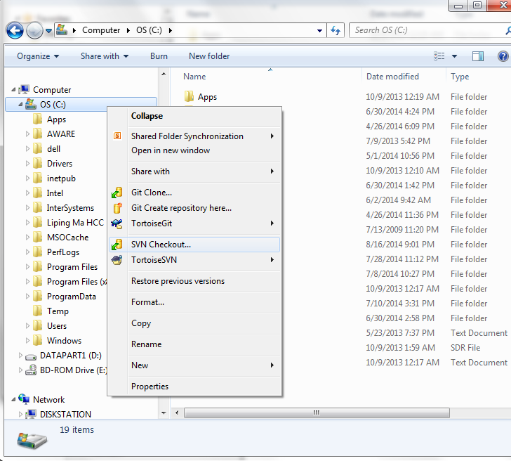
    - Enter URL of SVN repository (https://54.225.241.69/svn/aware) and checkout directory on your local machine (ex: c:\aware_sandbox). If you don’t have an SVN account, you need to establish an account with VA Innovation.
Figure 2 - SVN Checkout- SVN URL and Directory
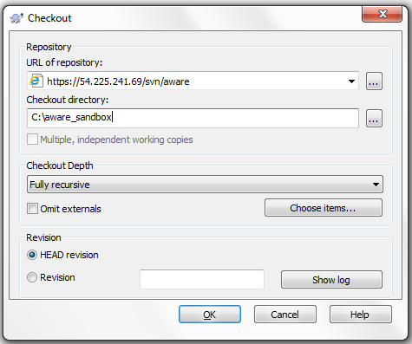
    - Click OK to download all the latest source code from Trunk.
- Double click on c:\aware_Sandbox\Trunk\QI Tool\QI Manager\AwareQIManager\ awareQIManager.sln to open the QI Manager solution.
- Update the application version with the new build version number in Web.config file under AwareQIManager project.
<add key="ApplicationVersion" value="1.1.5" />

- Rebuild the solution file. Make sure you see “Rebuild All succeeded” message on the bottom left.
Figure 3- Rebuild QI Manager Solution
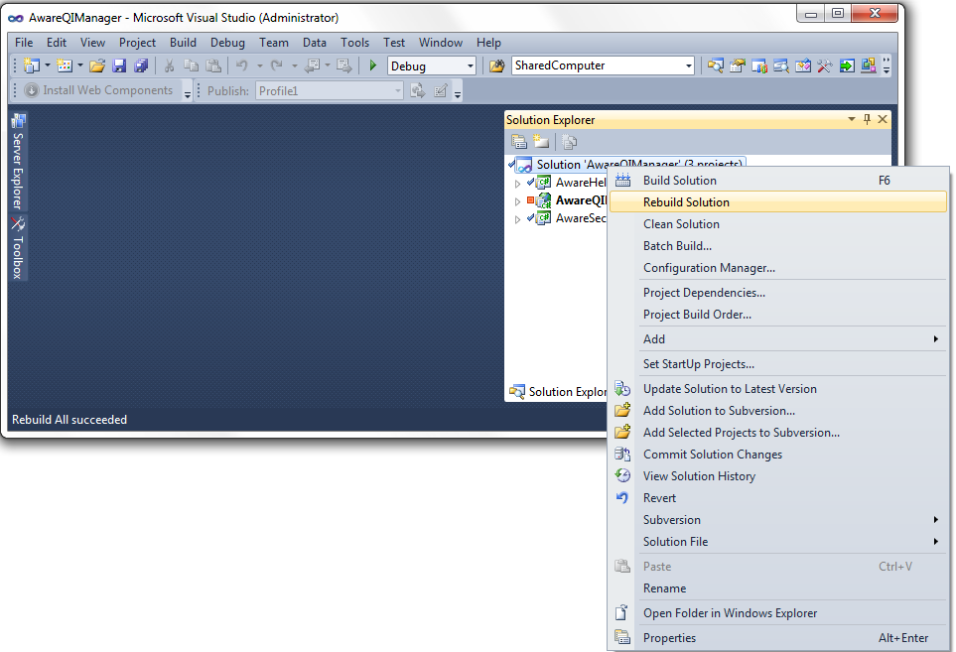
- Set up a QI Manager web site in IIS on your local machine.
  - Get a QI Manger deployment zip file from SVN. For example: C:\aware_sandbox\Deployment\AWARE Version 1.1.4\QI_Manager_v_1_4.zip
  - QI_Manager_v_1_4.zip to C:\inetpub\wwwroot folder and extract the content to the same folder.
Figure 4 - QI Manager Web Site Physical Location
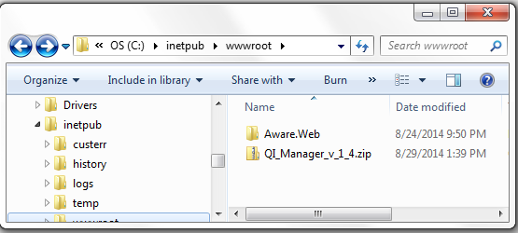
  - Set up the QI Manager web site in IIS. Add new site AWARE with the physical location C:\inetpub\wwwroot\Aware.Web.
Figure 5 - Set up QI Manager Web Site
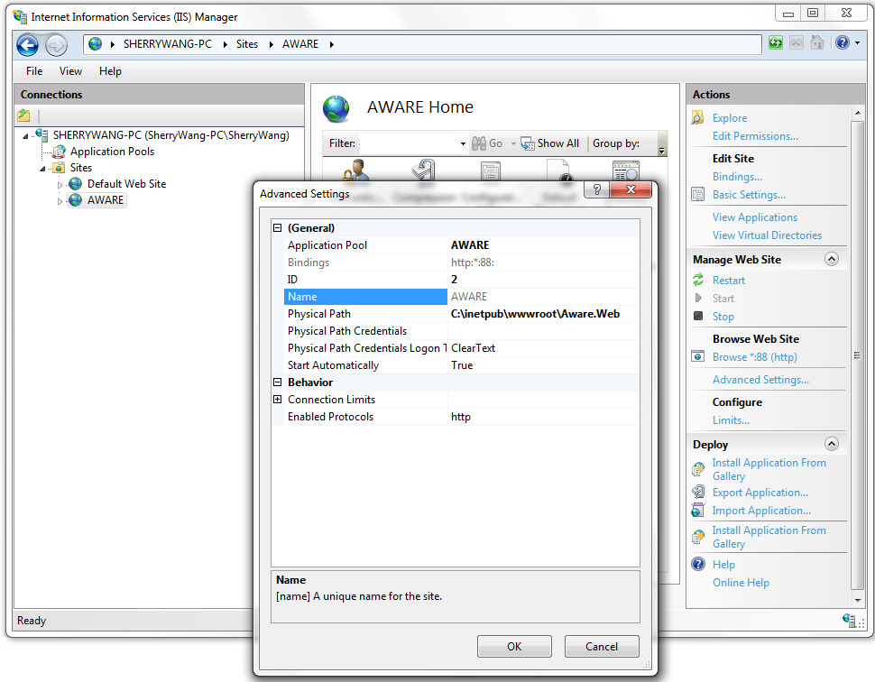
  - Verify the site is up and running. For example: Click “Browse *:88 (http)” in IIS from the above screenshot.
- Package the web application.
  - Publish the QI Manager web application from Visual Studio to IIS. Right click on AwareQIManger project and then click “Publish…” option. Set up Publish Profile correctly (see Figure 7) and then click on “Publish” button. Make sure you see publish succeeded message on the bottom left corner.
Figure 6 - Publish QI Manager
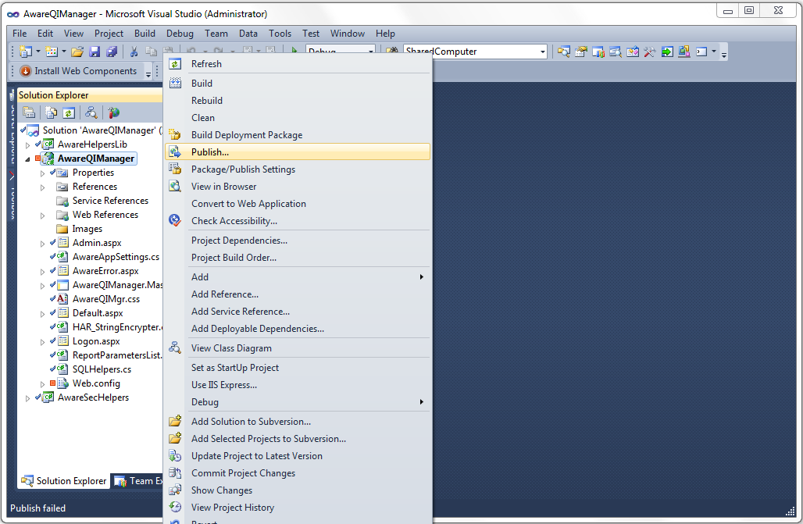
Figure 7 - Publish Profile
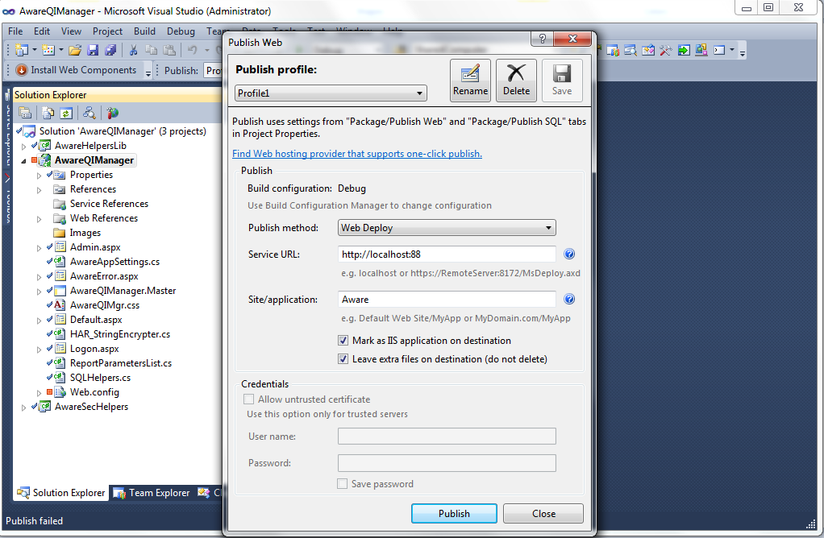
Figure 8 - Publish Succeeded
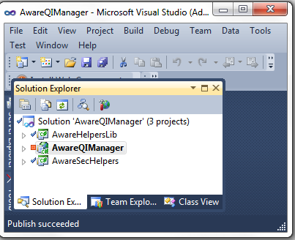
  - Restart AWARE web site in IIS. Browse the site and verify it is functioning as expected. Check the new build version number you updated in web.config file is correctly displayed on the log in page.
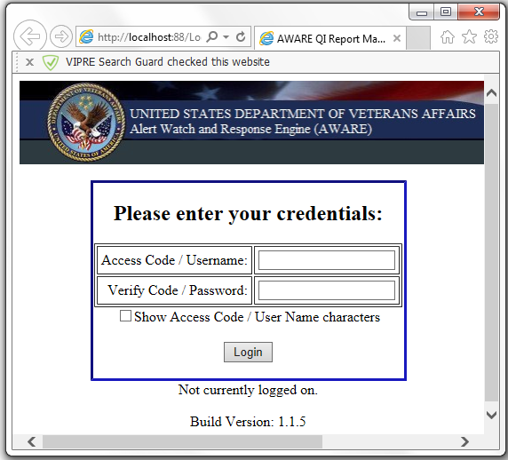
  - Go to the Physical path and zip the deployment file. Right click on “C:\inetpub\wwwroot\Aware.Web” folder and send it to a zipped folder “QI_Manager_v_1_5.zip”.
Figure 9 - Compress QI Manager Deployment Files
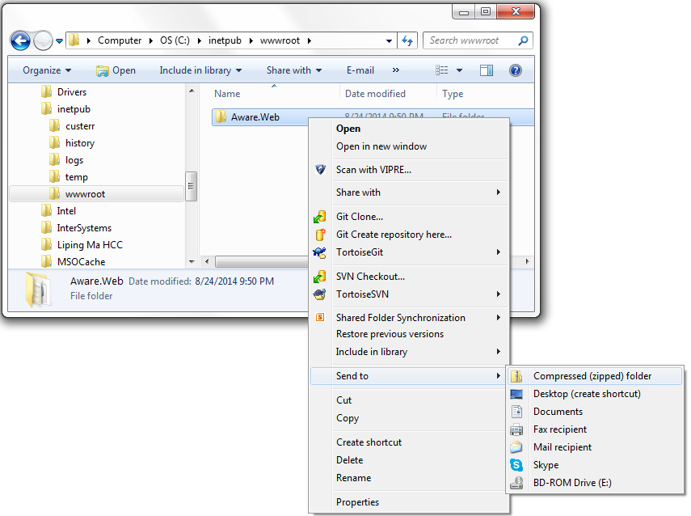
Figure 10 - QI Manager Deployment File
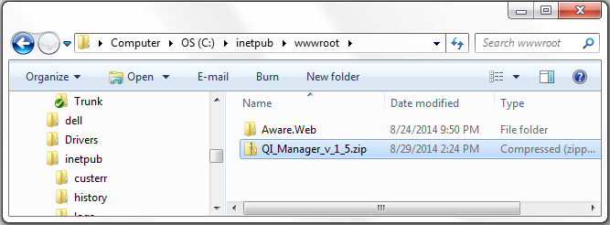
- Check in the new deployment zip file (example: QI_Manager_v_1_5.zip) to SVN deployment folder such as “\Deployment\AWARE Version 1.1.5”.

QI Reports Build Instruction
QI reports are SQL Server Reporting Service (SSRS) Reports which will be deployed to SSRS Reports Manager.
- Get the latest files from SVN by doing “SVN Update”.
- Create a new database script and name it as “<Build Version>_QIReportsVersion.sql”. For example, the file name for build version 1.1.5 reports is 115_QIReportsVersion.sql and the scripts is:
INSERT INTO [dbo].[APPLICATION_VERSION] ([VERSION_NUMBER],[CREATE_DATE]) VALUES ('1.1.5', GETDATE())
GO
- Add the above database script to “\Deployment\AWARE Version 1.1.5\QI_Database_Scripts_v_1_5.zip”. If the zip file does not exist already, create a new zip file.
- Copy a QI Reports deployment file from a previous build. For example, copy and rename “C:\aware_sandbox\Deployment\AWARE Version 1.1.3\QI_Reports_v_1_3.zip” to “C:\aware_sandbox\Deployment\AWARE Version 1.1.5\QI_Reports_v_1_5.zip”.
- Delete all the reports definitions files from “C:\aware_sandbox\Deployment\AWARE Version 1.1.5\QI_Reports_v_1_5.zip\QI_Reports\Aware” folder.
- Copy all the latest report definition files from source code folder to the zip folder. Example: from “C:\aware_sandbox\Trunk\QI Tool\QI Reports\AwareQIReports\*.rdl” to “C:\aware_sandbox\Deployment\AWARE Version 1.1.5\QI_Reports_v_1_5.zip\QI_Reports\Aware”.
- Check in the latest reports deployment files (example: QI_Database_Scripts_v_1_5.zip & QI_Reports_v_1_5.zip) to SVN deployment folder such as “\Deployment\AWARE Version 1.1.5”

SQL Transporter Build Instruction
The SQL Transporter is a Microsoft windows application which transfers alerts data from VistA to AWARE SQL Server database for each VA facility.
- Get the latest files from SVN by doing “SVN Update”.
- Copy a SQL Transporter deployment file from a previous build. For example, copy and rename “C:\aware_sandbox\Deployment\AWARE Version 1.1.4\QI_AWARE_SQL_Transporter_v_1_4.zip” to “C:\aware_sandbox\Deployment\AWARE Version 1.1.5\QI_AWARE_SQL_Transporter_v_1_5.zip”.
- Delete the following files from “C:\aware_sandbox\Deployment\AWARE Version 1.1.5\QI_AWARE_SQL_Transporter_v_1_5.zip” folder:
  - AWARE_SQL_Transporter.exe
  - AWARE_SQL_Transporter.exe.config
  - AWARE_SQL_Transporter.pdb
  - Interop.RPCSharedBrokerSessionMgr2.dll
- Build SQL Transporter.
  - Double click on “C:\aware_sandbox\Trunk\QI Tool\SQL Transporter\AWARE_SQL_Transporter.sln” to open the SQL transporter in Visual Studio.
  - Update the build version number. Open app.config file in Visual Studio and update the version number:
<setting name="ApplicationVersion" serializeAs="String">
<value>1.1.5</value>
</setting>
  - Rebuild AWARE_SQL_Transporter project. Right click on AWARE_SQL_Transporter project in Solution Explorer and click on “Rebuild” option. Make sure you see “Rebuild All succeeded” message on the bottom left corner.
Figure 11 - Rebuild SQL Transporter
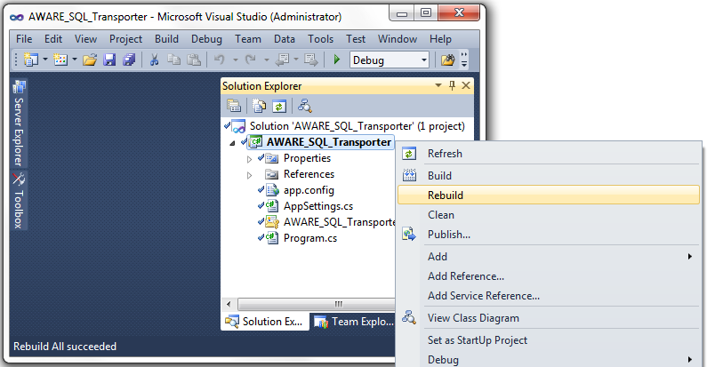
- Copy the following files from “C:\aware_sandbox\Trunk\QI Tool\SQL Transporter\AWARE_SQL_Transporter\bin\Debug” folder to “C:\aware_sandbox\Deployment\AWARE Version 1.1.5\QI_AWARE_SQL_Transporter_v_1_5.zip” folder:
  - AWARE_SQL_Transporter.exe
  - AWARE_SQL_Transporter.exe.config
  - AWARE_SQL_Transporter.pdb
  - Interop.RPCSharedBrokerSessionMgr2.dll
- Check in the latest SQL Transporter deployment file (example: QI_AWARE_SQL_Transporter_v_1_5.zip) to SVN deployment folder such as “\Deployment\AWARE Version 1.1.5”.

Vista Install Build Instructions

Initial Seeding Instructions for AWARE packages and Template Reminder Dialogs
If this is a virgin system for doing builds, you need to seed the “VistA Install Build” system from KIDs builds that have previously been built before. This is from KIDS and PRD files in the repository of AWARE deployment files taken from either the the KIDS_REMINDER_DIALOGS_v_1_x_VMS.zip, or KIDS_REMINDER_DIALOGS_v_1_x.zip as used with either OpenVMS or Linux, respectively. Extract all contents first into a local folder.
For seeding needed with making package builds as in the following sections 4.2, 4.3, and 4.4, you need to first do a onetime load and install of the following KIDs builds:
VEFA_1_0_xA.KID for Charleston baseline to realize the AWARE 1.2 package
VEFA_1_0_xB.KID for Longbeach baseline to realize the AWARE 1.x package
VEFA_1_0_x_KB.KID to realize the AWARE KB 1.x package
VEFA_TestData_1_0_x.KID to realize the VEFA TestData 1.x Multi-build package into a “Test” account only
This latter VEFA TestData 1.x multi-build package one time load and install is also shown in Appendix A Loading and Installing the VEFA TestData Multi-build Package
This will also load the following packages as part of this seeding process:
VEFA ZEVH 1.6
AWARE ORDERITEM 1.0
AWARE ORDERDIALOG 1.0
For seeding needed with Template Reminder Dialog building for section 4.5 you need to load a base set of Reminder Dialog .PRD files as described in Appendix B Loading Template Reminder Dialogs. This base set includes the following .PRD files:
- AVEFAC_PSA.PRD
- AVEFAC_FOBT-FIT.PRD
- AVEFAC_ABNORMAL_CXR.PRD
- AVEFAC_ABNORMAL_MAMMOGRAM.PRD

VEFA_1_0_x.KID Build Instructions
- For making a VEFA_1_0_x.KID build from AWARE 1.X do the following
Be sure the lines below in VALIDTYPE AND VALIDCAT in routine VEFAALR4 with trailing “Q 1”

VALIDTYP(Y) ; SCREEN ON KIDS BUILD TO RETURN VALID VEFA TRACKED CRITICAL ALERT TYPES
I $P($G(^DIZ(19007,Y,0)),"^",1)="[PROSTATE SPECIFIC ANTIGEN]" Q 1
I $P($G(^DIZ(19007,Y,0)),"^",1)="[OCCULT BLOOD]" Q 1
;MOD 8/22/2014 GOW ADJUST NAME CHANGE CHEST 2 V TO CHEST 2 VIEWS FRONT
;I $P($G(^DIZ(19007,Y,0)),"^",1)="CHEST 2 V" Q 1
I $P($G(^DIZ(19007,Y,0)),"^",1)="CHEST 2 VIEWS FRONT" Q 1
;END MOD
I $P($G(^DIZ(19007,Y,0)),"^",1)="MAMMOGRAM" Q 1
;MOD 8/22/2014 GOW ALLOW RELAXING CRITERIA FOR SITES TO SAVE THEIR KB DATABASE FROM
;TEST ACOUNT WITH ADDITIONAL ALERT TYPES TO SAVE NEW KB DATA KIDS BUILD AND MOVE
;IT TO PRODUCTION. HOWEVER FOR SAVING ORIGINAL KB DATA KIDS FILE AS TEMPLATE KB
;DATABASE KIDS FILE, PUT BACK TO "Q 0"
;Q 0
Q 1
VALIDCAT(Y) ; SCREEN ON KIDS BUILD TO RETURN VALID VEFA ALERT CATEGORIES
I $P($G(^DIZ(19008,Y,0)),"^",1)="Abnl Imaging Reslt, Needs Attn:" Q 1
I $P($G(^DIZ(19008,Y,0)),"^",1)="Critical labs -" Q 1
;MOD 8/22/2014 GOW ALLOW RELAXING CRITERIA FOR SITES TO SAVE THEIR KB DATABASE FROM
;TEST ACOUNT WITH ADDITIONAL ALERT CATEGORIES TO SAVE NEW KB DATA KIDS BUILD AND MOVE
;IT TO PRODUCTION. HOWEVER FOR SAVING ORIGINAL KB DATA KIDS FILE AS TEMPLATE KB
;DATABASE KIDS FILE, PUT BACK TO "Q 0"
;Q 0
Q 1

- Cache Windows set to 14 in VEFA AWARE ALERT CACHE
as below:

INPUT TO WHAT FILE: VEFA AWARE ALERT CACHE// vefa
1 VEFA AWARE ALERT CACHE (16 entries)
2 VEFA AWARE ALERT PARAMETER (1 entry)
3 VEFA CRITICAL ALERT CATEGORY (3 entries)
4 VEFA Tracked Critical Alert (6 entries)
CHOOSE 1-4: 2 VEFA AWARE ALERT PARAMETER (1 entry)
EDIT WHICH FIELD: ALL// Cache WINDOW
THEN EDIT FIELD:

Select VEFA AWARE ALERT PARAMETER NAME: AWARE ALERT PARAMETER
CACHE WINDOW: 730// 14
- Now make a KIDS build.
Charleston as VEFA_1_0_xA.KID from AWARE 1.2
LongBeach as VEFA_1_0_xB.KID from AWARE 1.x
See example KIDS build as Appendix D KIDS File Build Example using VEFA_1_0_xA.KID or VEFA_1_0_xB.KID from AWARE 1.x as KIDS file name
- You can reset the Cache Window in the VEFA AWARE ALERT PARAMETER file if you want.

INPUT TO WHAT FILE: VEFA AWARE ALERT CACHE// vefa
1 VEFA AWARE ALERT CACHE (16 entries)
2 VEFA AWARE ALERT PARAMETER (1 entry)
3 VEFA CRITICAL ALERT CATEGORY (3 entries)
4 VEFA Tracked Critical Alert (6 entries)
CHOOSE 1-4: 2 VEFA AWARE ALERT PARAMETER (1 entry)
EDIT WHICH FIELD: ALL// Cache WINDOW
THEN EDIT FIELD:

Select VEFA AWARE ALERT PARAMETER NAME: AWARE ALERT PARAMETER
CACHE WINDOW: 14// 730

VEFA_1_0_x_KB.KID Build Instructions
- For making a VEFA_1_0_x_KB.KID build do the following
Be sure the lines below in VALIDTYPE AND VALIDCAT in routine VEFAALR4 with trailing “Q 0” so that the basic 4 alert entry types get saved

VALIDTYP(Y) ; SCREEN ON KIDS BUILD TO RETURN VALID VEFA TRACKED CRITICAL ALERT TYPES
I $P($G(^DIZ(19007,Y,0)),"^",1)="[PROSTATE SPECIFIC ANTIGEN]" Q 1
I $P($G(^DIZ(19007,Y,0)),"^",1)="[OCCULT BLOOD]" Q 1
;MOD 8/22/2014 GOW ADJUST NAME CHANGE CHEST 2 V TO CHEST 2 VIEWS FRONT
;I $P($G(^DIZ(19007,Y,0)),"^",1)="CHEST 2 V" Q 1
I $P($G(^DIZ(19007,Y,0)),"^",1)="CHEST 2 VIEWS FRONT" Q 1
;END MOD
I $P($G(^DIZ(19007,Y,0)),"^",1)="MAMMOGRAM" Q 1
;MOD 8/22/2014 GOW ALLOW RELAXING CRITERIA FOR SITES TO SAVE THEIR KB DATABASE FROM
;TEST ACOUNT WITH ADDITIONAL ALERT TYPES TO SAVE NEW KB DATA KIDS BUILD AND MOVE
;IT TO PRODUCTION. HOWEVER FOR SAVING ORIGINAL KB DATA KIDS FILE AS TEMPLATE KB
;DATABASE KIDS FILE, PUT BACK TO "Q 0"
Q 0
; Q 1
VALIDCAT(Y) ; SCREEN ON KIDS BUILD TO RETURN VALID VEFA ALERT CATEGORIES
I $P($G(^DIZ(19008,Y,0)),"^",1)="Abnl Imaging Reslt, Needs Attn:" Q 1
I $P($G(^DIZ(19008,Y,0)),"^",1)="Critical labs -" Q 1
;MOD 8/22/2014 GOW ALLOW RELAXING CRITERIA FOR SITES TO SAVE THEIR KB DATABASE FROM
;TEST ACOUNT WITH ADDITIONAL ALERT CATEGORIES TO SAVE NEW KB DATA KIDS BUILD AND MOVE
;IT TO PRODUCTION. HOWEVER FOR SAVING ORIGINAL KB DATA KIDS FILE AS TEMPLATE KB
;DATABASE KIDS FILE, PUT BACK TO "Q 0"
Q 0
; Q 1

- Edit 4 fields to null in each of 4 records in VEFA Tracked Critical Alert file as below:

Select VA FileMan <TEST ACCOUNT> Option: enter or Edit File Entries.
INPUT TO WHAT FILE: VEFA Tracked Critical Alert (? entries)
EDIT WHICH FIELD: ALL// TIU TEMPLATE
THEN EDIT WHICH FIELD: ALL// Reminder Dialog
THEN EDIT FIELD: ACTIVE
THEN EDIT FIELD: INITIATION DATE
THEN EDIT FIELD:
Select VEFA Tracked Critical Alert NAME: `1 [PROSTATE SPECIFIC ANTIGEN] or other site name
TIU TEMPLATE: AWARE ABNORMAL PSA // @
Reminder Dialog: AVEFA PSA // @
ACTIVE: YES// NO
INITIATION DATE: JUN 08, 2014//@
Select VEFA Tracked Critical Alert NAME: `2 [OCCULT BLOOD] or other site name

TIU TEMPLATE: AWARE ABNORMAL FOBT-FIT // @
Reminder Dialog: AVEFA FOBT-FIT//@
ACTIVE: YES// NO
INITIATION DATE: JUN 08, 2014//@
Select VEFA Tracked Critical Alert NAME: `3 CHEST 2 VIEWS FRONT or other site name

TIU TEMPLATE: AWARE ABNORMAL CXR // @
Reminder Dialog: AVEFA ABNORMAL CXR //@
ACTIVE: YES// NO
INITIATION DATE: JUN 08, 2014//@
Select VEFA Tracked Critical Alert NAME: `4 MAMMOGRAM or other site name

TIU TEMPLATE: AWARE ABNORMAL MAMMOGRAM //@
Reminder Dialog: AVEFA ABNORMAL MAMMOGRAM //@
ACTIVE: YES// NO
INITIATION DATE: JUN 08, 2014//@

- Make KIDS file as VEFA_1_0_x_KB.KID from AWARE KB 1.x

See example KIDS build as Appendix D KIDS File Build Example using VEFA_1_0_x_KB.KID from AWARE KB 1.x as KIDS file name

- Be sure the re-edit the lines below in VALIDTYPE AND VALIDCAT in routine VEFAALR4 with trailing “Q 1” so that the all alert entry types can get saved from Test account.

VALIDTYP(Y) ; SCREEN ON KIDS BUILD TO RETURN VALID VEFA TRACKED CRITICAL ALERT TYPES
I $P($G(^DIZ(19007,Y,0)),"^",1)="[PROSTATE SPECIFIC ANTIGEN]" Q 1
I $P($G(^DIZ(19007,Y,0)),"^",1)="[OCCULT BLOOD]" Q 1
;MOD 8/22/2014 GOW ADJUST NAME CHANGE CHEST 2 V TO CHEST 2 VIEWS FRONT
;I $P($G(^DIZ(19007,Y,0)),"^",1)="CHEST 2 V" Q 1
I $P($G(^DIZ(19007,Y,0)),"^",1)="CHEST 2 VIEWS FRONT" Q 1
;END MOD
I $P($G(^DIZ(19007,Y,0)),"^",1)="MAMMOGRAM" Q 1
;MOD 8/22/2014 GOW ALLOW RELAXING CRITERIA FOR SITES TO SAVE THEIR KB DATABASE FROM
;TEST ACOUNT WITH ADDITIONAL ALERT TYPES TO SAVE NEW KB DATA KIDS BUILD AND MOVE
;IT TO PRODUCTION. HOWEVER FOR SAVING ORIGINAL KB DATA KIDS FILE AS TEMPLATE KB
;DATABASE KIDS FILE, PUT BACK TO "Q 0"
; Q 0
Q 1
VALIDCAT(Y) ; SCREEN ON KIDS BUILD TO RETURN VALID VEFA ALERT CATEGORIES
I $P($G(^DIZ(19008,Y,0)),"^",1)="Abnl Imaging Reslt, Needs Attn:" Q 1
I $P($G(^DIZ(19008,Y,0)),"^",1)="Critical labs -" Q 1
;MOD 8/22/2014 GOW ALLOW RELAXING CRITERIA FOR SITES TO SAVE THEIR KB DATABASE FROM
;TEST ACOUNT WITH ADDITIONAL ALERT CATEGORIES TO SAVE NEW KB DATA KIDS BUILD AND MOVE
;IT TO PRODUCTION. HOWEVER FOR SAVING ORIGINAL KB DATA KIDS FILE AS TEMPLATE KB
;DATABASE KIDS FILE, PUT BACK TO "Q 0"
; Q 0
Q 1

- Now place values back into VEFA TRACKED CRITICAL ALERT file as below:
VEFA TRACKED CRITICAL ALERT file to restore the previously edited values as in bold with the former values as noted before. See example editing as below:
Select VA FileMan <TEST ACCOUNT> Option: enter or Edit File Entries.
INPUT TO WHAT FILE: VEFA Tracked Critical Alert (? entries)
EDIT WHICH FIELD: ALL// TIU TEMPLATE
THEN EDIT WHICH FIELD: ALL// Reminder Dialog
THEN EDIT FIELD: ACTIVE
THEN EDIT FIELD: INITIATION DATE
THEN EDIT FIELD:
Select VEFA Tracked Critical Alert NAME: `1 [PROSTATE SPECIFIC ANTIGEN] or other site name
TIU TEMPLATE: // AWARE ABNORMAL PSA
Reminder Dialog: //AVEFA PSA
ACTIVE: NO// YES
INITIATION DATE: ////← enter previous Initiation Date value
Select VEFA Tracked Critical Alert NAME: `2 [OCCULT BLOOD] or other site name
TIU TEMPLATE: //AWARE ABNORMAL FOBT-FIT
Reminder Dialog: //AVEFA FOBT-FIT
ACTIVE: NO// YES
INITIATION DATE: ////← enter previous Initiation Date value
Select VEFA Tracked Critical Alert NAME: `3 CHEST 2 VIEWS FRONT or other site name
TIU TEMPLATE: //AWARE ABNORMAL CXR
Reminder Dialog: //AVEFA ABNORMAL CXR
ACTIVE: NO// YES
INITIATION DATE: //← enter previous Initiation Date value
Select VEFA Tracked Critical Alert NAME: `4 MAMMOGRAM or other site name
TIU TEMPLATE: //AWARE ABNORMAL MAMMOGRAM
Reminder Dialog: //AVEFA ABNORMAL MAMMOGRAM
ACTIVE: NO// YES
INITIATION DATE: ////← enter previous Initiation Date value

VEFA_TestData_1_0_x.KID Build Instructions
For making an VEFA_TESTDATA_1_x_KIDS file.
1. Edit a Build PAGE 1 OF 2
Name: AWARE TESTDATA 1.0 TYPE: MULTI-PACKAGE
-------------------------------------------------------------------------------
Name: AWARE TESTDATA 1.0

Date Distributed: NOV 24,2014
Description:
Required to
Install Order Packages or Patches Continue
1 VEFA ZEVH 1.6 YES
2 AWARE ORDERITEM 1.0 YES
3 AWARE ORDERDIALOG 1.0 YES

_______________________________________________________________________________
Edit a Build PAGE 2 of 2
Name: AWARE TESTDATA 1.0 TYPE: MULTI-PACKAGE
-------------------------------------------------------------------------------

Delete Routine
after install
Environment Check Routine: VEFACHKE Y/N: Yes
Pre-Install Routine: Y/N:
Post-Install Routine: Y/N:

_______________________________________________________________________________
COMMAND: Exit

Make a KIDS file
as VEFA_TESTDATA_1_0_x.KID from AWARE TESTDATA 1.x
See example KIDS build as Appendix D KIDS File Build Example using VEFA_TESTDATA_1_0_x.KID as KIDS file name

Reminder Dialog Build .PRD files Instructions
After making any updates to the Template Reminder Dialogs using the PXRM Dialog Management VistA option , you can make or remake the .PRD files using the instructions in Appendix C Generation of .PRD files.

Do this for the following Reminder Dialogs:
- AVEFA PSA
- AVEFA FOBT-FIT
- AVEFA ABNORMAL CXR
- AVEFAC ABNORMAL MAMMOGRAM

Into the analogous .PRD file names below:

- AVEFAC_PSA.PRD
- AVEFAC_FOBT-FIT.PRD
- AVEFAC_ABNORMAL_CXR.PRD
- AVEFAC_ABNORMAL_MAMMOGRAM.PRD

Appendix A Loading and Installing the VEFA TestData Multi-build Package
KIDS installation
1 Load a Distribution
2 Verify Checksums in Transport Global
3 Print Transport Global
4 Compare Transport Global to Current System
5 Backup a Transport Global
6 Install Package(s)
Restart Install of Package(s)
Unload a Distribution
You have PENDING ALERTS
Enter "VA to jump to VIEW ALERTS option

Select Installation <TEST ACCOUNT> Option: 1 Load a Distribution
Enter a Host File: D:\AWARE\KIDS\VMS\AWARE_1_1_5/VEFA_TESTDATA_1_0.KID

KIDS Distribution saved on Nov 24, 2014@00:17:12
Comment: VEFA Test Data only for Te

This Distribution contains Transport Globals for the following Package(s):
AWARE TESTDATA 1.0
VEFA ZEVH 1.6
AWARE ORDERITEM 1.0
AWARE ORDERDIALOG 1.0

Loading Distribution...
Build AWARE TESTDATA 1.0 has an Environmental Check Routine
Want to RUN the Environment Check Routine? YES//
AWARE TESTDATA 1.0
Will first run the Environment Check Routine, VEFACHKE
***Test Account Environment is fine***

VEFA ZEVH 1.6
AWARE ORDERITEM 1.0
AWARE ORDERDIALOG 1.0
Use INSTALL NAME: AWARE TESTDATA 1.0 to install this Distribution.

1 Load a Distribution
2 Verify Checksums in Transport Global
3 Print Transport Global
4 Compare Transport Global to Current System
5 Backup a Transport Global
6 Install Package(s)
Restart Install of Package(s)
Unload a Distribution

You have PENDING ALERTS
Enter "VA to jump to VIEW ALERTS option

Select Installation <TEST ACCOUNT> Option: INstall Package(s)
Select INSTALL NAME: AWARE TESTDATA 1.0 11/24/14@14:08:49
=> VEFA Test Data only for Test Account ;Created on Nov 24, 2014@00:17:1
This Distribution was loaded on Nov 24, 2014@14:08:49 with header of
VEFA Test Data only for Test Account ;Created on Nov 24, 2014@00:17:12
It consisted of the following Install(s):
AWARE TESTDATA 1.0 VEFA ZEVH 1.6AWARE ORDERITEM 1.0AWARE ORDERDIALOG 1.0
Checking Install for Package AWARE TESTDATA 1.0
Will first run the Environment Check Routine, VEFACHKE
***Test Account Environment is fine***
Install Questions for AWARE TESTDATA 1.0
Checking Install for Package VEFA ZEVH 1.6
Install Questions for VEFA ZEVH 1.6
Want KIDS to Rebuild Menu Trees Upon Completion of Install? NO//
Checking Install for Package AWARE ORDERITEM 1.0
Install Questions for AWARE ORDERITEM 1.0
Incoming Files:
101.43 ORDERABLE ITEMS (including data)
Note: You already have the 'ORDERABLE ITEMS' File.
I will OVERWRITE your data with mine.
Checking Install for Package AWARE ORDERDIALOG 1.0
Install Questions for AWARE ORDERDIALOG 1.0
Incoming Files:
101.41 ORDER DIALOG (including data)
Note: You already have the 'ORDER DIALOG' File.
I will OVERWRITE your data with mine.
Want KIDS to INHIBIT LOGONs during the install? NO//
Want to DISABLE Scheduled Options, Menu Options, and Protocols? NO//
Enter the Device you want to print the Install messages.
You can queue the install by enter a 'Q' at the device prompt.
Enter a '^' to abort the install.
DEVICE: HOME// CONSOLE
.....................................................
AWARE ORDERDIALOG 1.0
qqqqqqqqqqqqqqqqqqqqqqqqqqqqqqqqqqqqqqqqqqqqqqqqqqqqqqqqqqqqqqqqqqqqqqqqqqqqqqqq
AWARE ORDERDIALOG 1.0 Installed.
Nov 24, 2014@14:10:52
No link to PACKAGE file
NO Install Message sent
Updating Routine file...
Updating KIDS files...
AWARE TESTDATA 1.0 Installed.
Nov 24, 2014@14:10:52
No link to PACKAGE file
NO Install Message sent
qqqqqqqqqqqqqqqqqqqqqqqqqqqqqqqqqqqqqqqqqqqqqqqqqqqqqqqqqqqqqqqqqqqqqqqqqqqqqqqqqqqqqqqqqqqqqqqqqqqqqqqqqqqqqqqqqqqqqqqqqqqqqqqqqqqqqqqqqqqk
100% x 25 50 75 x
Complete mqqqqqqqqqqqqqqqqqqqqqqqqqqqqqqqqqqqqqqqqqqqqqqqqqqqqqqqqqqqqj
Install Completed

Appendix B Loading Template Reminder Dialogs
Perform the steps described below in order to load each of the four (4) Reminder Dialog .PRD files.

Last login: Wed Jun 4 15:18:48 2014 from 173.252.156.129
Node: I20082VSTLNX, Instance: CACHEINV
Username: CacheMgr
Password: *********

Select OPTION NAME: ?
Answer with OPTION NAME, or UPPERCASE MENU TEXT
Do you want the entire 11028-Entry OPTION List? N (No)

Select OPTION NAME: TRAINING
1 TRAINING DATA ENTRY FOR MFH HBHC MFH TRAINING INPUT Training Data
Entry for MFH
2 TRAINING MENU ZZ TRAINING MENU Training Menu
3 TRAINING RECORDS ESP TRAINING MENU Training Records
4 TRAINING REPORT BY SERVICE PRSE-SERV-TRAIN-RPT Training Report by Service
5 TRAINING REPORT BY UNIT/SVC. C NURSE-PR-MILOC Training Report by Unit/Svc. Category
CHOOSE 1-5: 2 ZZ TRAINING MENU Training Menu

PCE Basic PCE Hands-On ...
AICS Encounter Forms ...
OE CPRS Manager Menu ...
PX Reminder Managers Menu ...
XX General Parameter Tools ...
Select Training Menu <TEST ACCOUNT> Option: PX Reminder Managers Menu
CF Reminder Computed Finding Management ...
RM Reminder Definition Management ...
SM Reminder Sponsor Management ...
TXM Reminder Taxonomy Management ...
TRM Reminder Term Management ...
LM Reminder Location List Management ...
RX Reminder Exchange
RT Reminder Test
OS Other Supporting Menus ...
INFO Reminder Information Only Menu ...
DM Reminder Dialog Management ...
CP CPRS Reminder Configuration ...
RP Reminder Reports ...
MST Reminders MST Synchronization Management ...
PL Reminder Patient List Menu ...
PAR Reminder Parameters ...
ROC Reminder Order Check Menu ...
XM Reminder Extract Menu ...
GEC GEC Referral Report

Select Reminder Managers Menu <TEST ACCOUNT> Option: RX Reminder Exchange

Clinical Reminder Exchange Jun 04, 2014@16:44:50 Page: 1 of 7
Exchange File Entries.

Item Entry Source Date Packed
1 COLONOSCOPY F/U REMINDER1 GUILLORY@VA PACIFIC I 05/18/2010@12:28
2 COLONOSCOPY REPEAT DUE1 GUILLORY@VA PACIFIC I 05/18/2010@12:24
3 DEPRESSION/PTSD REMINDER TERM VOLPP@NORTHERN CAL 02/26/2010@12:07
UPDATES - PATCH 17
4 GMTS FOR HRMH THOMPSON@SALT LAKE CI 12/01/2011@11:10
5 NATIONAL BLOOD PRESSURE MONTGOMERY@TUSCALOOSA 04/05/2011@13:20
CHANGES
6 PXRM*2*17 COMPUTED FINDINGS REDINGTON@SALT LAKE CI 01/26/2010@11:49
7 VA BRANCHING LOGIC REMINDER VOLPP@NORTHERN CAL 09/13/2010@11:42
UPDATES OEF/OIF
+ + Next Screen - Prev Screen ?? More Actions >>>
CFE Create Exchange File Entry IH Installation History
CHF Create Host File LHF Load Host File
CMM Create MailMan Message LMM Load MailMan Message
DFE Delete Exchange File Entry LR List Reminder Definitions
IFE Install Exchange File Entry RI Reminder Definition Inquiry
Select Action: Next Screen// LHF
Enter a path: C:/HFS/// /srv/vista/inv/dat2/AVEFAC_PSA.PRD

A host file is a file on your host system.
A complete host file consists of a path, file name, and extension.
A path consists of a device and directory name.
The default extension is PRD.
The default path is C:/HFS/

Enter a path: C:/HFS/// USER$:[VMSUSERS.XXXXX]←-example path address (either a VMS or Linux account as appropriate site folder holding the .PRD files)
The following PRD files were found in /srv/vista/inv/dat2/
AVEFAC_ABNORMAL_CXR.PRD
AVEFAC_ABNORMAL_MAMMOGRAM.PRD
AVEFAC_FOBT-FIT.PRD
AVEFAC_PSA.PRD
Enter a file name: AVEFAC_PSA.PRD

Clinical Reminder Exchange Jun 04, 2014@16:48:34 Page: 1 of 8
Host file USER$:[VMSUSERS.XXXXX]AVEFAC_PSA.PRD <successfully loaded.

Item Entry Source Date Packed
1 AVEFAC PSA INNOVATIONS@CAMP MASTER 05/19/2014@19:47
2 COLONOSCOPY F/U REMINDER1 GUILLORY@VA PACIFIC I 05/18/2010@12:28
3 COLONOSCOPY REPEAT DUE1 GUILLORY@VA PACIFIC I 05/18/2010@12:24
4 DEPRESSION/PTSD REMINDER TERM VOLPP@NORTHERN CAL 02/26/2010@12:07
UPDATES - PATCH 17
5 GMTS FOR HRMH THOMPSON@SALT LAKE CI 12/01/2011@11:10
6 NATIONAL BLOOD PRESSURE MONTGOMERY@TUSCALOOSA 04/05/2011@13:20
CHANGES
7 PXRM*2*17 COMPUTED FINDINGS REDINGTON@SALT LAKE CI 01/26/2010@11:49
8 VA BRANCHING LOGIC REMINDER VOLPP@NORTHERN CAL 09/13/2010@11:42
+ + Next Screen - Prev Screen ?? More Actions >>>
CFE Create Exchange File Entry IH Installation History
CHF Create Host File LHF Load Host File
CMM Create MailMan Message LMM Load MailMan Message
DFE Delete Exchange File Entry LR List Reminder Definitions
IFE Install Exchange File Entry RI Reminder Definition Inquiry
Select Action: Next Screen// IFE Install Exchange File Entry
Select Entry(s): (1-8): 1

Exchange File Components Jun 04, 2014@16:49:58 Page: 1 of 9
Component Category Exists
Source: INNOVATIONS,VHA at CAMP MASTER
Date Packed: 05/19/2014@19:47:47
Package Version: 2.0P30

Description:
AVEFAC PSA
Non-exchangeable order dialog(s):
-----------------------------------------------------------------------
Name: VEFA URINALYSIS
Type: Quick Order
Display Text: Urinalysis
Display Group: CHEMISTRY
Package: LAB SERVICE
Lab Test: VEFA URINALYSIS
Collected By: Send patient to lab
Collection Sample: URINE
+ Enter ?? for more actions >>>
IA Install all Components IS Install Selected Component
Select Action: Next Screen//
Exchange File Components Jun 04, 2014@16:50:23 Page: 2 of 9
+ Component Category Exists
Specimen: URINE
How often: ONCE
-----------------------------------------------------------------------
-----------------------------------------------------------------------
Name: VEFA CIPROFLOXACIN
Type: Quick Order
Display Text: Ciprofloxacin
Display Group: OUTPATIENT MEDICATIONS
Package: OUTPATIENT PHARMACY
Medication: CIPROFLOXACIN TAB 500MG
Instructions: 500MG ORAL (BY MOUTH)
Pick Up: WINDOW
Priority: ROUTINE
Comments: Take as directed.
-----------------------------------------------------------------------
-----------------------------------------------------------------------
+ + Next Screen - Prev Screen ?? More Actions >>>
IA Install all Components IS Install Selected Component
Select Action: Next Screen//
Exchange File Components Jun 04, 2014@16:50:46 Page: 3 of 9
+ Component Category Exists
Name: VEFA Urine Culture and Susceptibility
Type: Quick Order
Display Text: Urine Culture and Susceptibility
Display Group: MICROBIOLOGY
Package: LAB SERVICE
Lab Test: VEFA CULTURE & SUSCEPTIBILITY
Collected By: Send patient to lab
Collection Sample: URINE
Specimen: URINE
How often: ONCE
-----------------------------------------------------------------------
-----------------------------------------------------------------------
Name: VEFA SULFAMETHOXAZOLE/TRIMETHOPRIM
Type: Quick Order
Display Text: Trimethoprim/Sulfamethoxazole
Display Group: OUTPATIENT MEDICATIONS
+ + Next Screen - Prev Screen ?? More Actions >>>
IA Install all Components IS Install Selected Component
Select Action: Next Screen//
Exchange File Components Jun 04, 2014@16:51:13 Page: 4 of 9

+ Component Category Exists
Package: OUTPATIENT PHARMACY
Medication: SULFAMETHOXAZOLE/TRIMETHOPRIM TAB
Dispense Drug: SULFAMETHOXAZOLE 800/TRIMETH 160MG TAB
Instructions: 1 TABLET SULFAMETHOXAZOLE 800/TRIMETH 160MG TAB OR
Days Supply: 5
Quantity: 10
Refills: 0
Pick Up: MAIL
Priority: ROUTINE
-----------------------------------------------------------------------
-----------------------------------------------------------------------
Name: VEFA Urology Consult
Type: Quick Order
Display Text: Urology Consult
Display Group: CONSULTS
Package: CONSULT/REQUEST TRACKING
+ + Next Screen - Prev Screen ?? More Actions >>>
IA Install all Components IS Install Selected Component
Select Action: Next Screen//
Exchange File Components Jun 04, 2014@16:51:39 Page: 5 of 9

+ Component Category Exists
Consult to Service/Specialty: SURGERY
Consult Type: Urology
Reason for Request: Abnormal PSA
Category: OUTPATIENT
Urgency: ROUTINE
Earliest appropriate date:TODAY
Place of Consultation: Consultant's Choice
Provisional Diagnosis: Elevated PSA
-----------------------------------------------------------------------
-----------------------------------------------------------------------
Name: VEFA PSA
Type: Quick Order
Display Text: Reorder PSA
Display Group: CHEMISTRY
Package: LAB SERVICE
Lab Test: VEFA PROSTATE SPECIFIC ANTIGEN
+ + Next Screen - Prev Screen ?? More Actions >>>
IA Install all Components IS Install Selected Component
Select Action: Next Screen//
Exchange File Components Jun 04, 2014@16:51:55 Page: 6 of 9

+ Component Category Exists
Collected By: Send patient to lab
Collection Sample: BLOOD
Specimen: SERUM
How often: NOW
-----------------------------------------------------------------------
-----------------------------------------------------------------------
Name: VEFA RADIATION ONCOLOGY CONSULT
Type: Quick Order
Display Text: Radiation/Oncology Consult
Display Group: CONSULTS
Package: CONSULT/REQUEST TRACKING
Consult to Service/Specialty: VEFA RADIOLOGY ONCOLOGY
Reason for Request: SUSPICIOUS PSA
Urgency: ROUTINE
Earliest appropriate date:TODAY
Place of Consultation: Consultant's Choice
+ + Next Screen - Prev Screen ?? More Actions >>>
IA Install all Components IS Install Selected Component
Select Action: Next Screen//
Exchange File Components Jun 04, 2014@16:52:12 Page: 7 of 9

+ Component Category Exists
Provisional Diagnosis: Suspicious PSA
-----------------------------------------------------------------------

Keywords:
PSA

Components:

ORDER DIALOG
VEFA RADIATION ONCOLOGY CONSULT
VEFA SULFAMETHOXAZOLE/TRIMETHOPRIM
VEFA PSA
VEFA CIPROFLOXACIN
VEFA URINALYSIS
VEFA Urine Culture and Susceptibility
VEFA Urology Consult
+ + Next Screen - Prev Screen ?? More Actions >>>
IA Install all Components IS Install Selected Component
Select Action: Next Screen//
Exchange File Components Jun 04, 2014@16:52:39 Page: 8 of 9

+ Component Category Exists
ORDER DIALOG
VEFA RADIATION ONCOLOGY CONSULT X
VEFA SULFAMETHOXAZOLE/TRIMETHOPRIM X
VEFA PSA X
VEFA CIPROFLOXACIN X
VEFA URINALYSIS X
VEFA Urine Culture and Susceptibility X
VEFA Urology Consult X

ORDERABLE ITEMS
VEFA RADIOLOGY ONCOLOGY X
VEFA SULFAMETHOXAZOLE/TRIMETHOPRIM TAB X
VEFA PROSTATE SPECIFIC ANTIGEN X
VEFA CIPROFLOXACIN TAB X
VEFA URINALYSIS X
VEFA CULTURE & SUSCEPTIBILITY X
VEFA Urology Consult X

HEALTH FACTORS
1 REMINDER FACTORS X
2 AW500 PSA OTHER FOLLOW-UP COMMENTS
3 AW500 PSA PAT OPTED NO TREATMENT
4 AW500 PSA PAT NO LONGER IN CARE
5 AW500 PSA LIMITED LIFE
+ + Next Screen - Prev Screen ?? More Actions >>>
IA Install all Components IS Install Selected Component
Select Action: Next Screen//
Exchange File Components Jun 04, 2014@17:36:42 Page: 9 of 9

+ Component Category Exists
6 AW500 PSA FOLLOWUP
7 AW500 PSA REFER TO ANOTHER VA PROVIDER
8 AW500 PSA DISCUSSED WITH PAT
9 AW500 PSA RADIATION ONCOLOGY CSLT
10 AW500 PSA SULFAMETHOXAZOLE/TRIMETH
11 AW500 PSA REORDER PSA
12 AW500 PSA ORDER CIPROFLOACIN
13 AW500 PSA ORDER URINALYSIS
14 AW500 PSA ORDER URINE CULTURE
15 AW500 PSA ORDER UROLOGY CONSULT

REMINDER DIALOG
16 AVEFA PSA

+ Next Screen - Prev Screen ?? More Actions >>>
IA Install all Components IS Install Selected Component
Select Action: Quit// IA
Exchange File Components Nov 24, 2014@15:08:47 Page: 8 of 9

All dialog components for AVEFA PSA are new.
Install reminder dialog and all components with no further changes: Y//
+ Component Category Exists

ORDERABLE ITEMS
VEFA RADIOLOGY ONCOLOGY X
VEFA SULFAMETHOXAZOLE/TRIMETHOPRIM TAB X
VEFA PROSTATE SPECIFIC ANTIGEN X
VEFA CIPROFLOXACIN TAB X
VEFA URINALYSIS X
VEFA CULTURE & SUSCEPTIBILITY X
VEFA Urology Consult X

+ + Next Screen - Prev Screen ?? More Actions >>>
IA Install all Components IS Install Selected Component
Select Action: Next Screen// IA Install all Components
HEALTH FACTORS entry named REMINDER FACTORS already exists and the
packed component is identical, skipping.

HEALTH FACTORS entry AW500 PSA OTHER FOLLOW-UP COMMENTS is NEW,
what do you want to do?

Select one of the following:

C Create a new entry by copying to a new name
I Install
Q Quit the install
S Skip, do not install this entry

Enter response: I// Install

HEALTH FACTORS entry AW500 PSA PAT OPTED NO TREATMENT is NEW,
what do you want to do?

Select one of the following:

C Create a new entry by copying to a new name
I Install
Q Quit the install
S Skip, do not install this entry

Enter response: I// Install

HEALTH FACTORS entry AW500 PSA PAT NO LONGER IN CARE is NEW,
what do you want to do?

Select one of the following:

C Create a new entry by copying to a new name
I Install
Q Quit the install
S Skip, do not install this entry

Enter response: I// Install

HEALTH FACTORS entry AW500 PSA LIMITED LIFE is NEW,
what do you want to do?

Select one of the following:

C Create a new entry by copying to a new name
I Install
Q Quit the install
S Skip, do not install this entry

Enter response: I// nstall

HEALTH FACTORS entry AW500 PSA FOLLOWUP is NEW,
what do you want to do?

Select one of the following:

C Create a new entry by copying to a new name
I Install
Q Quit the install
S Skip, do not install this entry

Enter response: I// nstall

HEALTH FACTORS entry AW500 PSA REFER TO ANOTHER VA PROVIDER is NEW,
what do you want to do?

Select one of the following:

C Create a new entry by copying to a new name
I Install
Q Quit the install
S Skip, do not install this entry

Enter response: I// nstall

HEALTH FACTORS entry AW500 PSA DISCUSSED WITH PAT is NEW,
what do you want to do?

Select one of the following:

C Create a new entry by copying to a new name
I Install
Q Quit the install
S Skip, do not install this entry

Enter response: I// nstall

HEALTH FACTORS entry AW500 PSA RADIATION ONCOLOGY CSLT is NEW,
what do you want to do?

Select one of the following:

C Create a new entry by copying to a new name
I Install
Q Quit the install
S Skip, do not install this entry

Enter response: I// nstall

HEALTH FACTORS entry AW500 PSA SULFAMETHOXAZOLE/TRIMETH is NEW,
what do you want to do?

Select one of the following:

C Create a new entry by copying to a new name
I Install
Q Quit the install
S Skip, do not install this entry

Enter response: I// nstall

HEALTH FACTORS entry AW500 PSA REORDER PSA is NEW,
what do you want to do?

Select one of the following:

C Create a new entry by copying to a new name
I Install
Q Quit the install
S Skip, do not install this entry

Enter response: I// nstall

HEALTH FACTORS entry AW500 PSA ORDER CIPROFLOACIN is NEW,
what do you want to do?

Select one of the following:

C Create a new entry by copying to a new name
I Install
Q Quit the install
S Skip, do not install this entry

Enter response: I// nstall

HEALTH FACTORS entry AW500 PSA ORDER URINALYSIS is NEW,
what do you want to do?

Select one of the following:

C Create a new entry by copying to a new name
I Install
Q Quit the install
S Skip, do not install this entry

Enter response: I// nstall

HEALTH FACTORS entry AW500 PSA ORDER URINE CULTURE is NEW,
what do you want to do?

Select one of the following:

C Create a new entry by copying to a new name
I Install
Q Quit the install
S Skip, do not install this entry

Enter response: I// nstall

HEALTH FACTORS entry AW500 PSA ORDER UROLOGY CONSULT is NEW,
what do you want to do?

Select one of the following:

C Create a new entry by copying to a new name
I Install
Q Quit the install
S Skip, do not install this entry

Enter response: I// nstall

Dialog Components Nov 24, 2014@15:16:02 Page: 1 of 4
Packed reminder dialog: AVEFA PSA

Item Seq. Dialog Findings Type Exists
1 AVEFA PSA dialog X

2 1 AVEFA PSA ORDERS GROUP group X
Finding: *NONE*
3 1..5 AW500 PSA REPEAT PSA element X
Finding: VEFA PSA (ORDER DIALOG) X
Add. Finding: AW500 PSA REORDER PSA (HEALTH FACTOR) X
4 1.1 AW500 PSA ORDER UROLOGY CONSULT element X
Finding: VEFA Urology Consult (ORDERABLE ITEM) X
Add. Finding: AW500 PSA ORDER UROLOGY CONSULT (HEALTH X
FACTOR)
5 1.2 AW500 PSA ORDER URINE CULTURE element X
Finding: VEFA Urine Culture and Susceptibility (ORDER X
DIALOG)
Add. Finding: AW500 PSA ORDER URINE CULTURE (HEALTH FACTOR) X
+ + Next Screen - Prev Screen ?? More Actions
DD Dialog Details DT Dialog Text IS Install Selected
DF Dialog Findings DU Dialog Usage QU Quit
DS Dialog Summary IA Install All
Select Action: Next Screen//Q

Appendix C Generation of .PRD files

PCE Basic PCE Hands-On ...
AICS Encounter Forms ...
OE CPRS Manager Menu ...
PX Reminder Managers Menu ...
XX General Parameter Tools ...

You have PENDING ALERTS
Enter "VA to jump to VIEW ALERTS option

Select Training Menu <TEST ACCOUNT> Option: PX Reminder Managers Menu

CF Reminder Computed Finding Management ...
RM Reminder Definition Management ...
SM Reminder Sponsor Management ...
TXM Reminder Taxonomy Management ...
TRM Reminder Term Management ...
LM Reminder Location List Management ...
RX Reminder Exchange
RT Reminder Test
OS Other Supporting Menus ...
INFO Reminder Information Only Menu ...
DM Reminder Dialog Management ...
CP CPRS Reminder Configuration ...
RP Reminder Reports ...
MST Reminders MST Synchronization Management ...
PL Reminder Patient List Menu ...
PAR Reminder Parameters ...
ROC Reminder Order Check Menu ...
XM Reminder Extract Menu ...
GEC GEC Referral Report

You have PENDING ALERTS
Enter "VA to jump to VIEW ALERTS option

Select Reminder Managers Menu <TEST ACCOUNT> Option: RX Reminder Exchange

Clinical Reminder Exchange Jul 24, 2014@09:21:09 Page: 2 of 9
Exchange File Entries.

+Item Entry Source Date Packed
11 COLONOSCOPY F/U REMINDER1 GUILLORY@VA PACIFIC I 05/18/2010@12:28
12 COLONOSCOPY REPEAT DUE1 GUILLORY@VA PACIFIC I 05/18/2010@12:24
13 DEPRESSION/PTSD REMINDER TERM VOLPP@NORTHERN CAL 02/26/2010@12:07
UPDATES - PATCH 17
14 ECOE REMINDER DIALOGS CARTER@SALT LAKE CI 08/28/2013@09:38
15 GMTS FOR HRMH THOMPSON@SALT LAKE CI 12/01/2011@11:10
16 NATIONAL BLOOD PRESSURE MONTGOMERY@TUSCALOOSA 04/05/2011@13:20
CHANGES
17 PXRM*2*17 COMPUTED FINDINGS REDINGTON@SALT LAKE CI 01/26/2010@11:49
18 VA BRANCHING LOGIC REMINDER VOLPP@NORTHERN CAL 09/13/2010@11:42
+ + Next Screen - Prev Screen ?? More Actions >>>
CFE Create Exchange File Entry IH Installation History
CHF Create Host File LHF Load Host File
CMM Create MailMan Message LMM Load MailMan Message
DFE Delete Exchange File Entry LR List Reminder Definitions
IFE Install Exchange File Entry RI Reminder Definition Inquiry
Select Action: Next Screen//CFE

Select from the following reminder files:
1 REMINDER COMPUTED FINDINGS
2 REMINDER COUNTING GROUP
3 REMINDER DEFINITION
4 REMINDER DIALOG
5 REMINDER EXTRACT COUNTING RULE
6 REMINDER EXTRACT DEFINITION
7 REMINDER LIST RULE
8 REMINDER LOCATION LIST
9 REMINDER SPONSOR
10 REMINDER TAXONOMY
11 REMINDER TERM
12 REMINDER ORDER CHECK ITEMS GROUP
13 REMINDER ORDER CHECK RULES
Select a file: (1-13):4

1 AVEFA ABNORMAL CXR reminder dialog LOCAL
2 AVEFA ABNORMAL CXR GROUP dialog group LOCAL
3 AVEFA ABNORMAL MAMMOGRAM reminder dialog LOCAL
4 AVEFA FOBT FOLLOW-UP GROUP dialog group LOCAL
5 AVEFA FOBT FOLLOWUP COMMENTS GROUP dialog group LOCAL
Press <RETURN> to see more, '^' to exit this list, OR
CHOOSE 1-5: 1

CHOOSE 1-5: 1 AVEFA ABNORMAL CXR reminder dialog LOCAL
Enter another one or just press enter to go back to file selection.
Select REMINDER DIALOG NAME:
elect REMINDER DIALOG NAME:

Select from the following reminder files:
1 REMINDER COMPUTED FINDINGS
2 REMINDER COUNTING GROUP
3 REMINDER DEFINITION
4 REMINDER DIALOG
5 REMINDER EXTRACT COUNTING RULE
6 REMINDER EXTRACT DEFINITION
7 REMINDER LIST RULE
8 REMINDER LOCATION LIST
9 REMINDER SPONSOR
10 REMINDER TAXONOMY
11 REMINDER TERM
12 REMINDER ORDER CHECK ITEMS GROUP
13 REMINDER ORDER CHECK RULES
Select a file: (1-13):
hecking reminder dialog(s) for errors..
No problems found.
Enter the Exchange File entry name: AVEFA ABNORMAL CXR//
Enter a description of the REMINDER DIALOG you are packing.
1>ABN CHEST XRAY
2>
EDIT Option:
Enter keywords or phrases to help index the entry you are packing.
Separate the keywords or phrases on each line with commas.
1>ABN CHEST XRAY

2>
EDIT Option:
Packing components ...
Adding ORDER DIALOG VEFA ORDER CHEST BIOPSY, IEN=15704
Adding ORDER DIALOG VEFA CARDIO-THORACIC SURG-CSLT, IEN=15702
Adding ORDER DIALOG VEFA Heme-Onc Consult, IEN=15693
Adding ORDER DIALOG VEFA GMRCT PULMONARY, IEN=391
Adding ORDER DIALOG VEFA RA58 Chest PA&LAT, IEN=390
Adding ORDER DIALOG VEFA RA CT CHEST, IEN=15692
Adding ORDERABLE ITEMS VEFA BIOPSY CHEST FLUORO NEEDLE, IEN=5064
Adding ORDERABLE ITEMS VEFA CARDIO-THORACIC SURG CSLT, IEN=5075
Adding ORDERABLE ITEMS VEFA HEMATOLOGY CONSULT, IEN=5071
Adding ORDERABLE ITEMS VEFA PULMONARY, IEN=5056
Adding ORDERABLE ITEMS VEFA CHEST 2 VIEWS PA&LAT, IEN=5063
Adding ORDERABLE ITEMS VEFA CT THORAX W/O CONT, IEN=5065
Adding HEALTH FACTORS REMINDER FACTORS, IEN=41
Adding HEALTH FACTORS AW500 CXRY OTHER FOLLOW-UP COMMENTS, IEN=500188
Adding HEALTH FACTORS AW500 CXRY PAT OPTED NO TREATMENT, IEN=500190
Adding HEALTH FACTORS AW500 CXRY PAT NO LONGER IN CARE, IEN=500189
Adding HEALTH FACTORS AW500 CXRY LIMITED LIFE, IEN=500186
Adding HEALTH FACTORS AW500 CXRY FOLLOWUP, IEN=500185
Adding HEALTH FACTORS AW500 CXRY REFER TO ANOTHER VA PROVIDER, IEN=500191
Adding HEALTH FACTORS AW500 CXRY DISCUSSED WITH PAT, IEN=500182
Adding HEALTH FACTORS AW500 CXRY ORDER CHEST BIOPSY, IEN=500170
Adding HEALTH FACTORS AW500 CXRY CARDIOTHORACIC SURG CSLT, IEN=500169
Adding HEALTH FACTORS AW500 CXRY CHEST X-RAY NO FINDINGS, IEN=500172
Adding HEALTH FACTORS AW500 CXRY ORDER HEME-ONC CONSULT, IEN=500150
Adding HEALTH FACTORS AW500 CXRY ORDER PULMONOLOGY CONSULT, IEN=500149
Adding HEALTH FACTORS AW500 CXRY REPEAT CXR, IEN=500151
Adding HEALTH FACTORS AW500 CXRY ORDER CT CHEST, IEN=500152
Adding REMINDER DIALOG PXRM COMMENT, IEN=1
Adding REMINDER DIALOG AW500 CXRY OTHER FOLLOW-UP COMMENTS, IEN=531
Adding REMINDER DIALOG AW500 CXRY FOLLOWUP COMMENTS GROUP, IEN=548
Adding REMINDER DIALOG AW500 CXRY PAT OPTED NO TREAT, IEN=560
Adding REMINDER DIALOG AW500 CXRY PAT NO LONGER IN CARE, IEN=557
Adding REMINDER DIALOG AW500 CXRY LIMITED LIFE, IEN=555
Adding REMINDER DIALOG AW500 CXRY FOLLOWUP, IEN=554
Adding REMINDER DIALOG AW500 CXRY REFER TO ANOTHER VA PROV, IEN=553
Adding REMINDER DIALOG AW500 CXRY DISCUSSED WITH PAT, IEN=552
Adding REMINDER DIALOG AW500 CXRY FOLLOW-UP GROUP, IEN=549
Adding REMINDER DIALOG AW500 CXRY ORDER CHEST BIOPSY OTHER, IEN=535
Adding REMINDER DIALOG AW500 CXRY CARDIO-THORACIC SURG CSLT, IEN=515
Adding REMINDER DIALOG AW500 CXRY CHEST RADIOGRAPH NO FINDING W MAL, IEN=521
Adding REMINDER DIALOG AW500 CXRY ORDER HEME-ONC CONSULT, IEN=516
Adding REMINDER DIALOG AW500 CXRY ORDER CHEST BIOPSY, IEN=517
Adding REMINDER DIALOG AW500 CXRY ORDER PULMONOLOGY CONSULT, IEN=518
Adding REMINDER DIALOG AW500 CXRY REPEAT CXR, IEN=519
Adding REMINDER DIALOG AW500 CXRY ORDER CT CHEST, IEN=520
Adding REMINDER DIALOG AVEFA ABNORMAL CXR GROUP, IEN=523
Adding REMINDER DIALOG AVEFA ABNORMAL CXR, IEN=524
Packing is complete.

Clinical Reminder Exchange Jul 24, 2014@09:27:05 Page: 2 of 9
AVEFA ABNORMAL CXR was saved in the Exchange File.

Item Entry Source Date Packed
1 AVEFA ABNORMAL CXR INNOVATIONS@CAMP MASTER 02/20/2014@15:32
2 AVEFAP ABNORMAL CXR PROD CLINCOORDINA@CAMP MASTER 07/24/2014@09:25
3 AVEFA ABNORMAL MAMMOGRAM INNOVATIONS@CAMP MASTER 02/27/2014@13:34
4 AVEFA FOBT-FIT INNOVATIONS@CAMP MASTER 02/20/2014@14:56
5 AVEFA PSA INNOVATIONS@CAMP MASTER 02/09/2014@10:21
6 AVEFA1 ABNORMAL CXR PROGRAMMER@CAMP MASTER 08/27/2011@11:10
7 AVEFAC ABNORMAL CXR INNOVATIONS@CAMP MASTER 05/19/2014@19:51
8 AVEFAC ABNORMAL MAMMOGRAM INNOVATIONS@CAMP MASTER 05/19/2014@19:52
9 AVEFAC FOBT-FIT INNOVATIONS@CAMP MASTER 05/19/2014@19:50
+ + Next Screen - Prev Screen ?? More Actions >>>
CFE Create Exchange File Entry IH Installation History
CHF Create Host File LHF Load Host File
CMM Create MailMan Message LMM Load MailMan Message
DFE Delete Exchange File Entry LR List Reminder Definitions
IFE Install Exchange File Entry RI Reminder Definition Inquiry
Select Action: Next Screen// CHF Create Host File
Select Entry(s): (1-9): 2
Enter a path: C:/HFS/// USER$:[VMSUSERS.XXXX] ←---- Enter appropriate directory pathname (such as for a VMS account)
Or
Enter a path: C:/HFS/// /srv/vista/inv/dat1/←---- Enter appropriate directory pathname (such as for a Linux account)

Enter a file name: AVEFA_ABNORMAL_CXR.PRD ←-- “.PRD” named file
in a VMS account
Host file is USER$:[VMSUSERS.XXXX]AVEFA_ABNORMAL_CXR.PRD is this correct?:
(such as for a VMS account)
or
Host file is /srv/vista/inv/dat1/AVEFA_ABNORMAL_CXR.PRD is this correct?:
(such as for a LINUX account)

Y//Y
Clinical Reminder Exchange Jul 24, 2014@10:37:01 Page: 1 of 9
Successfully stored entries 2

Item Entry Source Date Packed
1 AVEFA ABNORMAL CXR INNOVATIONS@CAMP MASTER 02/20/2014@15:32
2 AVEFAP ABNORMAL CXR PROD CLINCOORDINA@CAMP 07/24/2014@09:25
MASTER
3 AVEFA ABNORMAL MAMMOGRAM INNOVATIONS@CAMP MASTER 02/27/2014@13:34
4 AVEFA FOBT-FIT INNOVATIONS@CAMP MASTER 02/20/2014@14:56
5 AVEFA PSA INNOVATIONS@CAMP MASTER 02/09/2014@10:21
6 AVEFA1 ABNORMAL CXR PROGRAMMER@CAMP MASTER 08/27/2011@11:10
7 AVEFAC ABNORMAL CXR INNOVATIONS@CAMP MASTER 05/19/2014@19:51
8 AVEFAC ABNORMAL MAMMOGRAM INNOVATIONS@CAMP MASTER 05/19/2014@19:52
9 AVEFAC FOBT-FIT INNOVATIONS@CAMP MASTER 05/19/2014@19:50
+ + Next Screen - Prev Screen ?? More Actions >>>
CFE Create Exchange File Entry IH Installation History
CHF Create Host File LHF Load Host File
CMM Create MailMan Message LMM Load MailMan Message
DFE Delete Exchange File Entry LR List Reminder Definitions
IFE Install Exchange File Entry RI Reminder Definition Inquiry
Select Action: Next Screen// Q

Appendix D KIDS File Build Example
Setting up programmer environment
This is a TEST account.
Terminal Type set to: C-VT102

Select OPTION NAME: EVE
1 EVE Systems Manager Menu
CHOOSE 1-5: 1 EVE Systems Manager Menu

Core Applications ...
Device Management ...
FM VA FileMan ...
Menu Management ...
Programmer Options ...
Operations Management ...
Spool Management ...
Information Security Officer Menu ...
Taskman Management ...
HL7 Main Menu ...
User Management ...
Application Utilities ...
Capacity Planning ...
Manage Mailman ...
Enter "VA to jump to VIEW ALERTS option
Select Systems Manager Menu <TEST ACCOUNT> Option: PRogrammer Options

KIDS Kernel Installation & Distribution System ...
NTEG Build an 'NTEG' routine for a package
PG Programmer mode
Calculate and Show Checksum Values
Delete Unreferenced Options
Error Processing ...
Global Block Count
List Global
Map Pointer Relations
Number base changer
Routine Tools ...
Test an option not in your menu

Select Programmer Options <TEST ACCOUNT> Option: KIDS Kernel Installation &
Distribution System

Edits and Distribution ...
Utilities ...
Installation ...
Patch Monitor Main Menu ...
Select Kernel Installation & Distribution System <TEST ACCOUNT> Option: EDITs
and Distribution

Create a Build Using Namespace
Copy Build to Build
Edit a Build
Transport a Distribution
Old Checksum Update from Build
Old Checksum Edit
Routine Summary List
Version Number Update

You have PENDING ALERTS
Enter "VA to jump to VIEW ALERTS option
Select Edits and Distribution <TEST ACCOUNT> Option: TRANSport a Distribution
Enter the Package Names to be transported. The order in which
they are entered will be the order in which they are installed.

First Package Name: AWARE
1 AWARE 1.2
2 AWARE 1.3
3 AWARE HEALTH FACTORS 1.0
4 AWARE KB 1.2
5 AWARE KB 1.3
6 AWARE ORDERDIALOG 1.0
7 AWARE ORDERITEM 1.0
8 AWARE TESTDATA 1.0
CHOOSE 1-8:

CHOOSE 1-8: 2 AWARE 1.x (i.e. AWARE 1.3 for LongBeach)
or AWARE 1.2 (Charleston)
or AWARE KB 1.x(i.e. AWARE 1.3)
or AWARE TESTDATA 1.x( i.e. AWARE TESTDATA 1.0)
Another Package Name:
ORDER PACKAGE
- ←-particular package name
As AWARE 1.x (i.e. AWARE 1.3 for LongBeach)
or AWARE 1.2 (Charleston)
or AWARE KB 1.x(i.e. AWARE 1.3)
or AWARE TESTDATA 1.x( i.e. AWARE TESTDATA 1.0)

OK to continue? YES//
Transport through (HF)Host File or (PM)PackMan: HF Host File
Enter a Host File: C:\AWARE\KIDS FILE NAME
Where KIDS FILE NAME in named format respectively below:
VEFA_1_0_xA.KID (from AWARE 1.X for LongBeach) or
VEFA_1_0_xB.KID (from AWARE 1.2 for Charleston) or
VEFA_1_0_x_KB.KID ( from AWARE KB 1.x) or
VEFA_TESTDATA_1_0_x.KID ( from AWARE TESTDATA 1.x)
Transport Successfully made

CSP Gateway Client-side Package Install Build Instruction
Alert Cache Viewer and KB Editor are AWARE Web Applications are written in CSP. On the client side, they are using Open Source Javascript libraries such as JQuery and JQGrid. These libraries need to be installed on the Web Server CSP Gateway. There is a separate installation document (T4_AWARE_InstallGde-Server) describe how to install and setup the AWARE Client-side package (VEFA_IIS_V_1_x.ZIP) on CSP Gateway. The following instruction describes how to create this package:
- Get the latest VEFA_IIS_V_1_x.ZIP file from SVN by doing “SVN Update”. The “x” in the filename is an incremental number version.
- Extract the ZIP file into a development folder.
- Add and/or replace Javascript files in the folder.
- Create a new VEFA_IIS_V_1_X.ZIP file. For the new file, increment the “x”.
- Add the above file to “\Deployment\AWARE Version 1.1.x\.
- Remove the older version of the zip file if it exists on the new Deployment folder.

CSP Install Build Instruction
AWARE CSP is the server-side web content producer. It provides dynamic data to Alert Cache Viewer and KB Editor. The underlying CSP codes are stored in VEFA_CSPTEST_V_1_x.XML (for test account) and VEFA_CSP_V_1_x.XML (for production account). Other than the CSP location, both XML files are identical. The following instruction describes how to update the contents and recreate both packages:

CSP Build for Production Account
- Create CSP application (csp/aware) has not been created, add the CSP Application.
  - Right click Cache Cube and select System Management Portal.
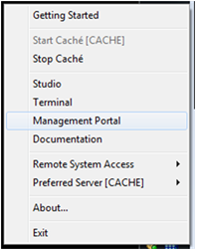
Figure 12 – Cache Management Portal

  - Select Cache Preferred Server. This is the Cache Server where the Web Application will be installed on.
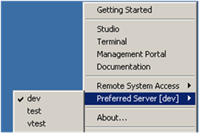
Figure 13 - Select Preferred Server

  - Access Web Application by traversing System Administration, Security, Applications, Web Applications, and click on GO button to add Web application.
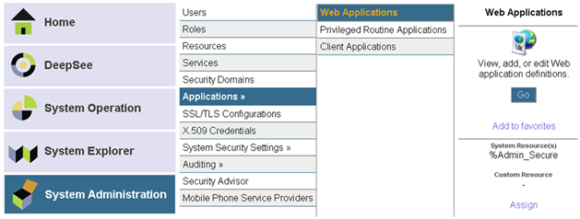
Figure 14 - CSP Web Application

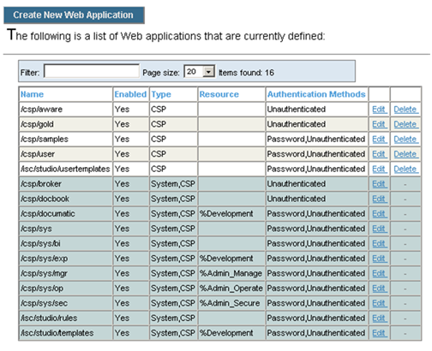
Figure 15 - List of Web Applications

  - Click Create New Web Application button.
The example below is from the sandbox I2008 VistA Amazon cloud-2 environment.
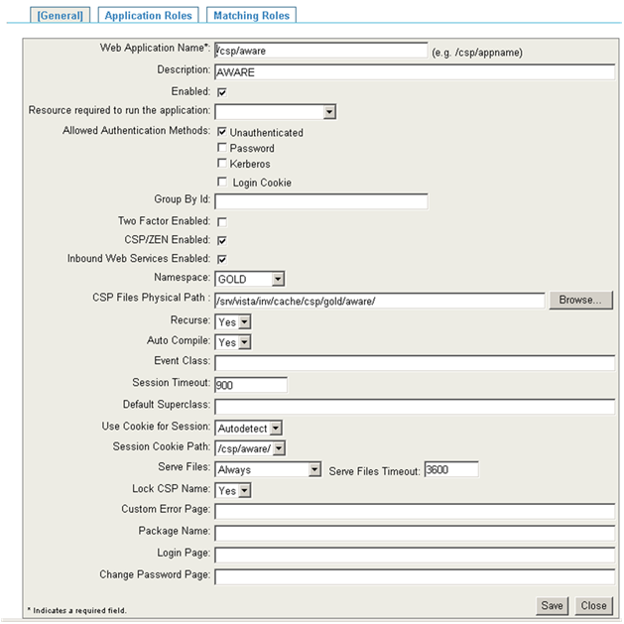
Figure 16 - Create New Web Applicatioion
  - Change the Namespace and CSP Files Physical Path to reflect appropriate namespace and path.
The structure of the path depends on the OS where Cache Server is installed.
For Windows: <drive>:\<cache-install-dir>\CSP\aware\
For UNIX: /<Cache Install-dir>/csp/aware/
For VMS: adjust appropriately. Example: XXX_CACHE$:[XXX.CSP.AWARE] where XXX indicates the 3 characters site identifier
  - Click Save.
  - Click on the Application Roles tab and select %DB_%DEFAULT then click Assign button.
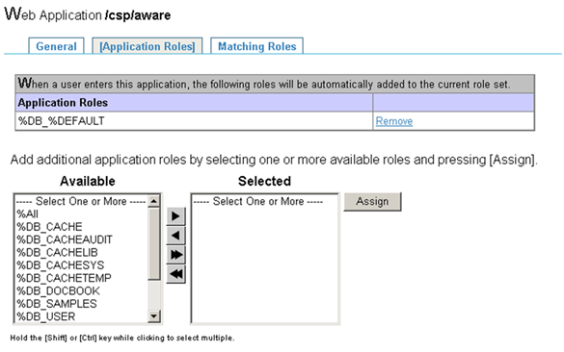
Figure 17 - Web Application Role
  - The CSP application is now configured for AWARE Web Application.

- Get the latest VEFA_CSP_V_1_x.XML file from SVN by doing “SVN Update”. The “x” in the filename is an incremental number version.
- Import the XML file. Use Cache Studio to import source code XML.
  - Right click Cache Cube and select Studio.
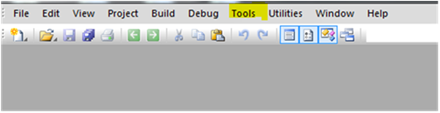
Figure 18 - Cache Studio
  - Select Cache Namespace where CSP source code will be imported.
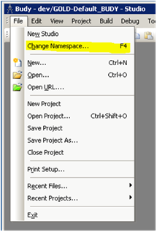
Figure 19 – Change Cache Namespace

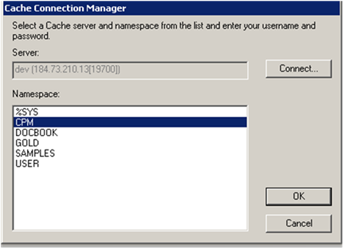
Figure 20 - Select Cache Namespace

  - Click the Tool menu and select Import Local.
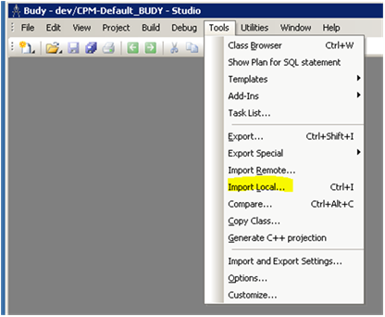
Figure 21 - Import CSP for Production Account

  - Browse and find the previously downloaded VEFA_CSP_V_1_x.XML source code. The “x” in the filename represents the last increment.
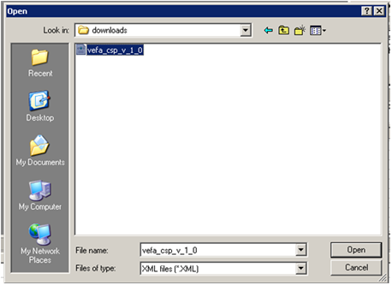
Figure 22 - Select CSP XML file to Import

  - Click the Open button.
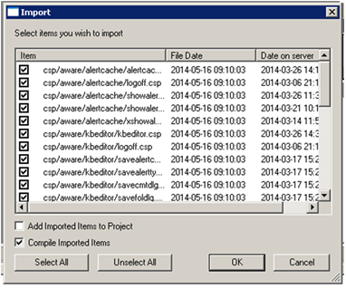
Figure 23 - Import CSP AWARE Dialog
  - Verify the Add Imported Items to Project checkbox is not selected.
  - Click the OK button to import the KB Editor and Alert Cache Viewer CSP source files.

- Using Cache Studio, update the contents of the csp/aware/kbeditor and the /csp/aware/alertcache for the new version.
- Build VEFA_CSP_V_1_x.XML. Increment the “x” to a newer version) by exporting all CSP and cls files:
  - Open Cache Studio, select Tools and Export…, traverse to csp/aware then click on Add button
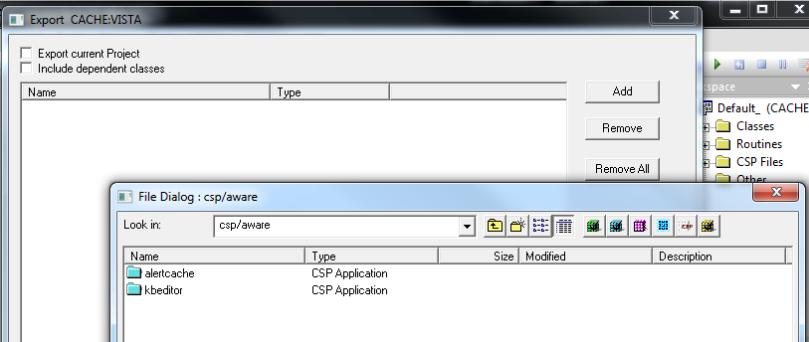
Figure 24 – Traverse to csp/aware AlertCache

  - Select all csp files on alertcache folder
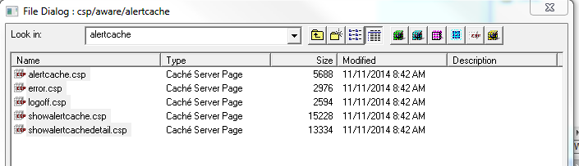
Figure 25 - Select all Alert Cache Viewer CSP files for Production Account

  - Select all csp files on kbeditor folder
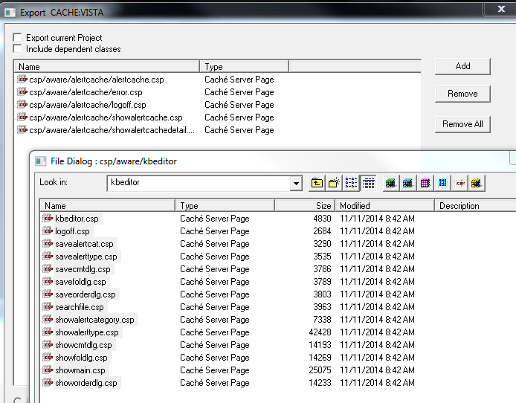
Figure 26 – Select all KB Editor CSP files for Production Account

  - Traverse back to the root for the development instance and open VEFA folder
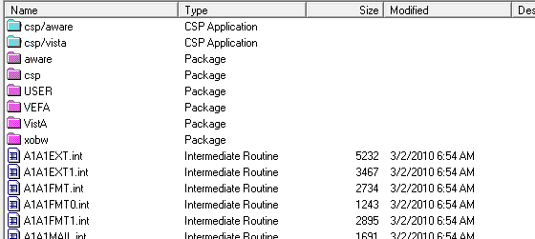
Figure 27- Select VEFA folder for Production

  - Select all cls files from VEFA
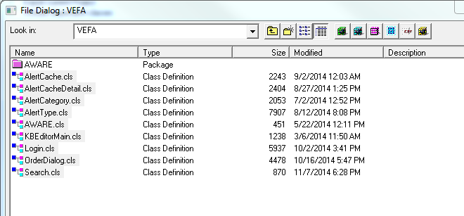
Figure 28 – Select all cls files for Production Account

  - Save all csp and cls files to VEFA_CSP_V_1_x.XML
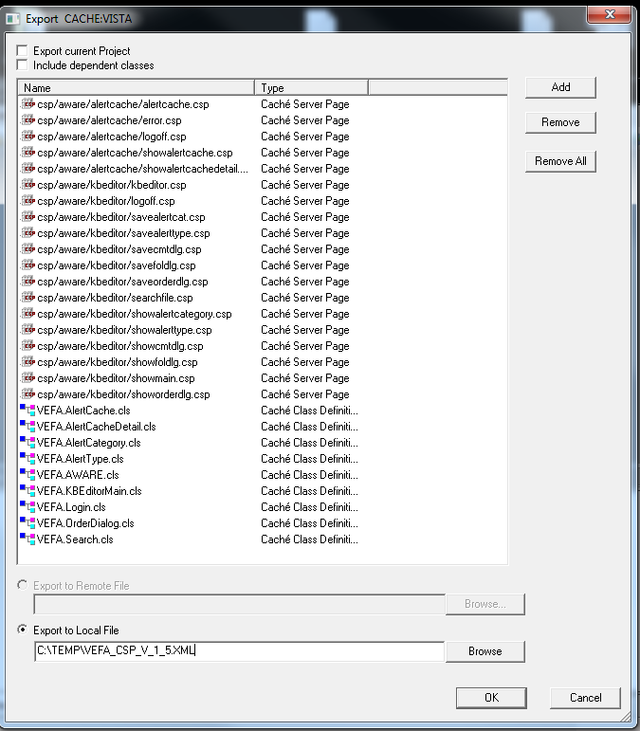
Figure 29 - Deploy CSP AWARE for Production Account

- Add the newly created VEFA_CSP_V_1_x.XML to “\Deployment\AWARE Version 1.1.x\.
- Remove the older version of the XML file if they exist on the new Deployment folder.

CSP Build for Test Account
The VEFA_CSPTEST_V_1_x.XML (deployment file for Test Account) could be created using the same development account, even though for testing purposes, using separate development account for the CSPTEST is preferable. The following steps describe how to create the VEFA_CSPTEST_V_1_x.XML build. If using the same development account, skip step 1 and 2
  - Repeat Step 1 of Section 6.1 above to create Web Application. Caution: use /csp/aware for the name. Do not change the name to other than /csp/aware.
  - Load the newly created VEFA_CSP_V_1_x.XML from Step 5 of Section 6.1. See Step 3 of Section 6.1 on how to load an XML file.
  - Edit the CSP Web application from /csp/aware to /csptest/aware
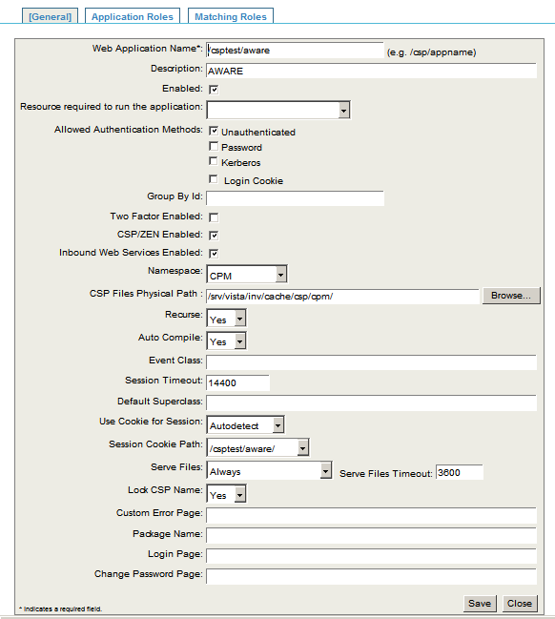
Figure 30 - CSP WEB Application for Test Account

  - Change the Namespace and CSP Files Physical Path to reflect appropriate namespace and path.
The structure of the path depends on the OS where Cache Server is installed.
For Windows: <drive>:\<cache-install-dir>\CSP\aware\
For UNIX: /<Cache Install-dir>/csp/aware/
For VMS: adjust appropriately. Example: XXX_CACHE$:[XXX.CSP.AWARE] where XXX indicates the 3 characters site identifier
  - Click Save.
  - Click on the Application Roles tab and select %DB_%DEFAULT then click Assign button.
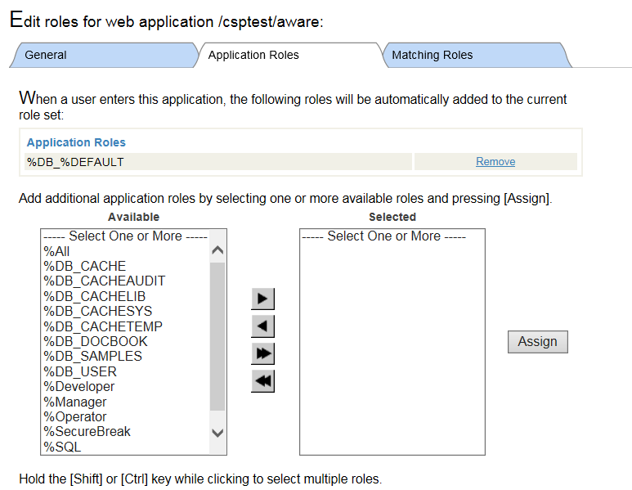
Figure 31 – Web Application Role for Test Account

  - The CSPTEST application is now configured for AWARE Web Application.
  - Build VEFA_CSPTEST_V_1_x.XML. Increment the “x” to a newer version) by exporting all CSP and cls files:
  - Open Cache Studio, select Tools and Export…, traverse to csptest/aware then click on Add button
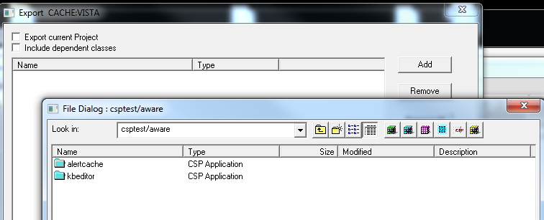
Figure 32 - Export Alert Cache Viewer for Test Account

  - Select all csp files on alertcache folder
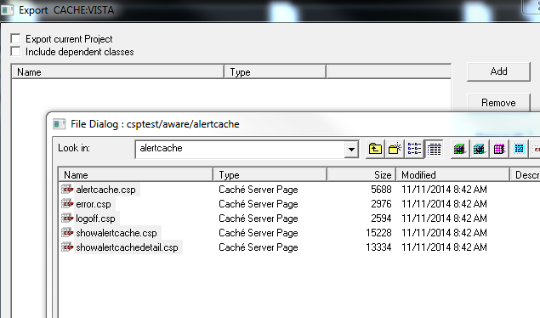
Figure 33 - Select Alert Cache Viewer CSP files for Test Account

  - Select all csp files on kbeditor folder
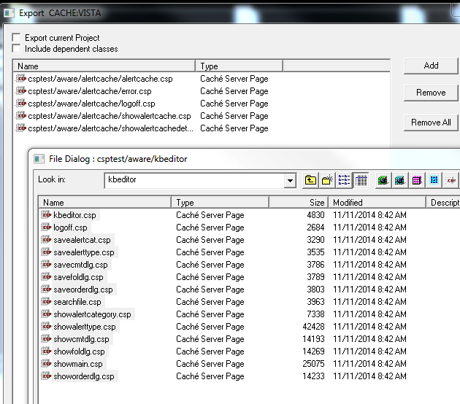
Figure 34 – Select KB Editor CSP files for Test Account
  - Traverse back to the root for the development instance and open VEFA folder
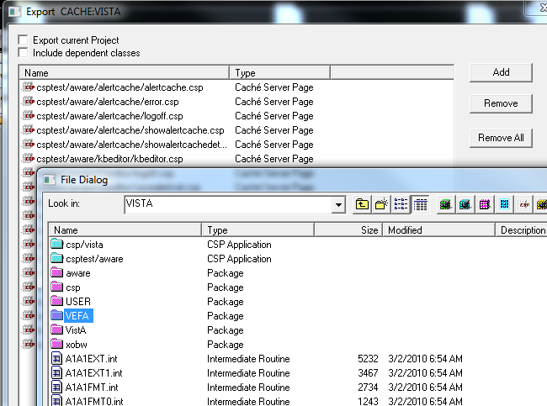
Figure 35 – Select VEFA folder for Test Account

  - Select all cls files from VEFA
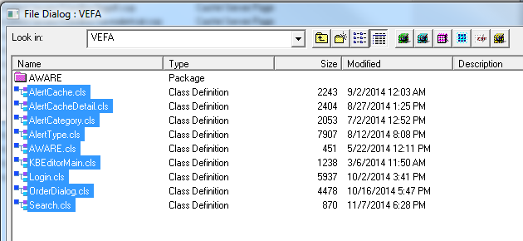
Figure 36 – Select all cls files for Test Account

  - Save all csp and cls files to VEFA_CSPTEST_V_1_x.XML
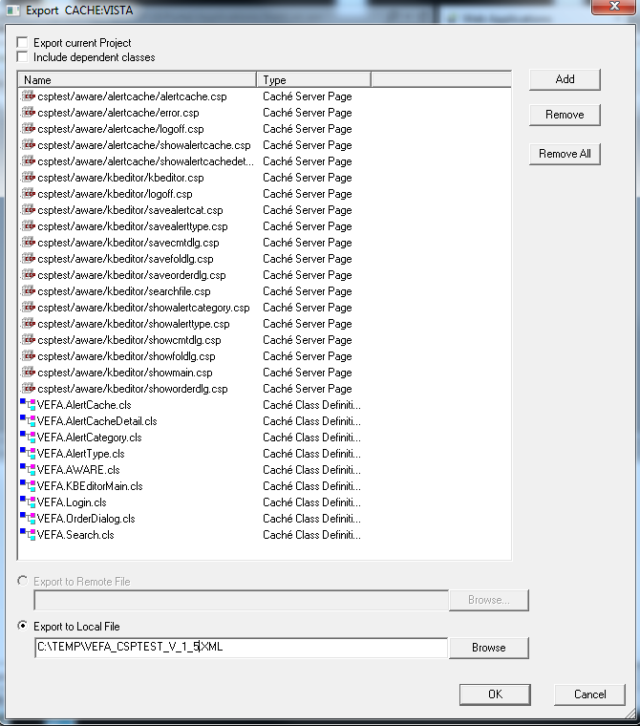
Figure 37 – Deploy CSP AWARE for Test Account

  - Add the newly created VEFA_CSPTEST_V_1_x.XML to “\Deployment\AWARE Version 1.1.x\.
  - Remove the older version of the XML file if they exist on the new Deployment folder.

Terms, Acronyms, Abbreviations, and Definitions
Table 1 – Terms, Acronyms, Abbreviations, and Definitions
Terms, Acronyms, Abbreviations | Definitions
AWARE | Alert Watch and Response Engine
CSP | Intersystems Cache Server Page
QI | Quality Improvement
IIS | Internet Information Services
MS SQL | Microsoft Structured Query Language
SSRS | SQL Server Reporting Services
VA | Veterans Affairs
VHA | Veterans Health Administration
SVN | Apache Subversion

